**Lab 4**

**Theory**

PHP is a server-side scripting language that can be embedded into HTML and interact with databases. It is widely used for web development and is open source, meaning that it is free to use and modify. PHP supports various features such as objects, functions, operators, and control structures. PHP can also generate different types of output, such as images, PDF files, or XML. PHP (Hypertext Preprocessor) is a versatile and widely-used server-side scripting language for creating dynamic and interactive web applications. Whether you’re a seasoned developer or a beginner eager to delve into the world of web development, this PHP tutorial is your gateway to mastering the intricacies of PHP programming.

**Task 1:**

**Create a database Student and create a Table (Table 1) in MySQL having following:**

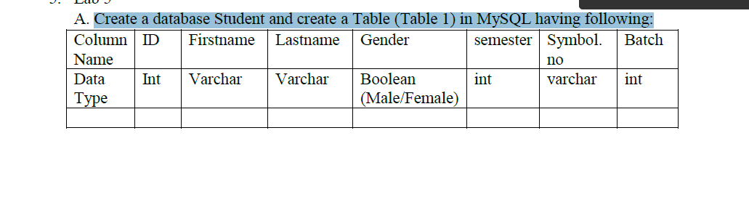

**PHP**

<?php

$servername = 'localhost';

$username = 'root';

$password = 'root';

$dbname = 'Student';

// Create_Connection

$conn = new mysqli($servername, $username, $password, $dbname);

// Check_Connection

if (!$conn) {

die("Connection failed: " . mysqli_connect_error());

}

// SQL to create table

$sql = "CREATE TABLE Table1 (

ID int,

Firstname Varchar(255),

Lastname VARCHAR(255),

Gender BOOLEAN,

Semester int,

Symbol VARCHAR(255),

Batch int

)";

// Check if the table creation query was successful

if (mysqli_query($conn, $sql)) {

echo "Table 'Table1' created successfully";

} else {

echo "Error creating table: " . mysqli_error($conn);

}

// Close the connection

mysqli_close($conn);

?>

**Task 2:**

**Create Separate Tables for Class and Batch containing ID, name.**

**PHP**

<?php

$servername = 'localhost';

$username = 'root';

$password = 'root';

$dbname = 'Student';

// Create connection

$conn = new mysqli($servername, $username, $password, $dbname);

// Check connection

if ($conn->connect_error) {

die("Connection error: " . $conn->connect_error);

}

// SQL to create table 'Class'

$sqlClass = "CREATE TABLE IF NOT EXISTS Class (

ID INT PRIMARY KEY AUTO_INCREMENT,

name VARCHAR(255)

)";

if (mysqli_query($conn, $sqlClass)) {

echo "Table 'Class' created successfully<br>";

} else {

echo "Error creating table 'Class': " . mysqli_error($conn) . "<br>";

}

// SQL to create table 'Batch'

$sqlBatch = "CREATE TABLE IF NOT EXISTS Batch (

ID INT PRIMARY KEY AUTO_INCREMENT,

name VARCHAR(255)

)";

if (mysqli_query($conn, $sqlBatch)) {

echo "Table 'Batch' created successfully<br>";

} else {

echo "Error creating table 'Batch': " . mysqli_error($conn) . "<br>";

}

// Close connection

mysqli_close($conn);

?>

**Task 3:**

**Create a Simple form (Form 1) in PHP having FirstName, Lastname, Gender (Radio Button), Class (dropdown), Roll Number and Batch (dropdown)**

**PHP**

<!DOCTYPE html>

<html lang="en">

<head>

<meta charset="UTF-8">

<meta name="viewport" content="width=device-width, initial-scale=1.0">

<title>Form 1</title>

</head>

<body>

<form action="process_form.php" method="post">

<label for="firstname">First Name:</label>

<input type="text" id="firstname" name="firstname"><br><br>

<label for="lastname">Last Name:</label>

<input type="text" id="lastname" name="lastname"><br><br>

<label>Gender:</label>

<input type="radio" id="male" name="gender" value="Male">

<label for="male">Male</label>

<input type="radio" id="female" name="gender" value="Female">

<label for="female">Female</label><br><br>

<label for="class">Class:</label>

<select id="class" name="class">

<option value="1">Class 1</option>

<option value="2">Class 2</option>

<!-- more class options as needed -->

</select><br><br>

<label for="rollnumber">Roll Number:</label>

<input type="text" id="rollnumber" name="rollnumber"><br><br>

<label for="batch">Batch:</label>

<select id="batch" name="batch">

<option value="A">Batch A</option>

<option value="B">Batch B</option>

<!-- more batch options as needed -->

</select><br><br>

<input type="submit" value="Submit">

</form>

</body>

</html>

**Output**

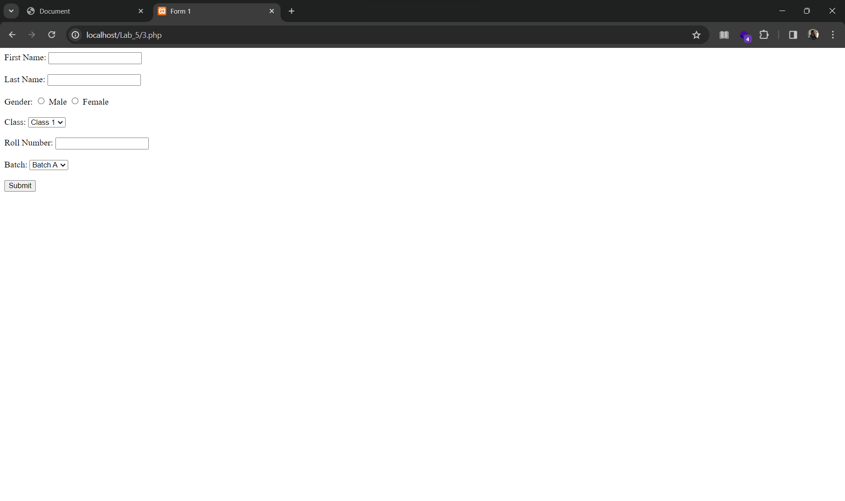

**Task 4:**

**Use Client Side required validation in the Form 1.**

**PHP**

<!DOCTYPE html>

<html lang="en">

<head>

<meta charset="UTF-8">

<meta name="viewport" content="width=device-width, initial-scale=1.0">

<title>Form Validation</title>

</head>

<body>

<form id="myForm" action="process_form.php" method="post" onsubmit="return validateForm()">

<label for="firstname">First Name:</label>

<input type="text" id="firstname" name="firstname"><br><br>

<label for="lastname">Last Name:</label>

<input type="text" id="lastname" name="lastname"><br><br>

<label>Gender:</label>

<input type="radio" id="male" name="gender" value="Male">

<label for="male">Male</label>

<input type="radio" id="female" name="gender" value="Female">

<label for="female">Female</label><br><br>

<label for="class">Class:</label>

<select id="class" name="class">

<option value="">Select Class</option>

<option value="1">Class 1</option>

<option value="2">Class 2</option>

<!-- Add more class options as needed -->

</select><br><br>

<label for="rollnumber">Roll Number:</label>

<input type="text" id="rollnumber" name="rollnumber" title="Please enter a 4-digit number"><br><br>

<label for="batch">Batch:</label>

<select id="batch" name="batch">

<option value="">Select Batch</option>

<option value="A">Batch A</option>

<option value="B">Batch B</option>

<!-- Add more batch options as needed -->

</select><br><br>

<input type="submit" value="Submit">

</form>

<script>

function validateForm() {

// Get values from the form

const firstname = document.getElementById('firstname').value;

const lastname = document.getElementById('lastname').value;

// Get the selected class value

const selectedClass = document.getElementById('class').value;

// Get the roll number

const rollnumber = document.getElementById('rollnumber').value;

// Get the selected batch value

const selectedBatch = document.getElementById('batch').value;

// Detailed validation

if (firstname === "" || lastname === "" || !gender || selectedClass === "" || rollnumber === "" ||

selectedBatch === "") {

alert("All fields must be filled out");

return false;

}

return true;

}

</script>

</body>

</html>

**Output**

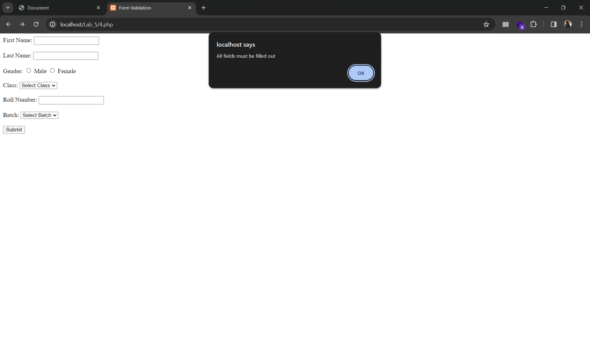

**Task 5:**

**Connect Database and Table 1 and insert the data filled in Form 1.**

**PHP**

***Form Submit***

<?php

$servername = "localhost";

$username = "root";

$password = "";

$dbname = "test";

// Create connection

$conn = mysqli_connect($servername, $username, $password);

// Check connection

if (!$conn) {

die("Connection error: " . mysqli_connect_error());

}

// Create database if it doesn't exist

$sqlCreateDatabase = "CREATE DATABASE IF NOT EXISTS $dbname";

if (mysqli_query($conn, $sqlCreateDatabase)) {

echo "Database created successfully or already exists<br>";

} else {

echo "Error creating database: " . mysqli_error($conn) . "<br>";

}

// Select the database

mysqli_select_db($conn, $dbname);

// Create 'Student' table

$sqlCreateTable = "CREATE TABLE Student (

id INT AUTO_INCREMENT PRIMARY KEY,

firstname VARCHAR(255),

lastname VARCHAR(255),

gender VARCHAR(10),

class VARCHAR(255),

rollnumber VARCHAR(20),

batch VARCHAR(20)

)";

if (mysqli_query($conn, $sqlCreateTable)) {

echo "Table created successfully or already exists<br>";

} else {

echo "Error creating table: " . mysqli_error($conn) . "<br>";

}

// Check if the form is submitted

if ($_SERVER["REQUEST_METHOD"] == "POST") {

$firstname = $_POST['firstname'];

$lastname = $_POST['lastname'];

$gender = $_POST['gender'];

$class = $_POST['class'];

$rollnumber = $_POST['rollnumber'];

$batch = $_POST['batch'];

// Insert values into the 'Student' table

$sqlInsert = "INSERT INTO Student (firstname, lastname, gender, class, rollnumber, batch)

VALUES ('$firstname', '$lastname', '$gender', '$class', '$rollnumber', '$batch')";

// Check the insertion query

if (mysqli_query($conn, $sqlInsert)) {

echo "New record created successfully";

} else {

echo "Error: " . $sqlInsert . "<br>" . mysqli_error($conn);

}

}

// Close connection

mysqli_close($conn);

?>

***Form***

<!DOCTYPE html>

<html lang="en">

<head>

<meta charset="UTF-8">

<meta name="viewport" content="width=device-width, initial-scale=1.0">

<title>Form Validation</title>

</head>

<body>

<form id="myForm" action="formSubmit.php" method="post" onsubmit="return validateForm()">

<label for="firstname">First Name:</label>

<input type="text" id="firstname" name="firstname"><br><br>

<label for="lastname">Last Name:</label>

<input type="text" id="lastname" name="lastname"><br><br>

<label>Gender:</label>

<input type="radio" id="male" name="gender" value="Male">

<label for="male">Male</label>

<input type="radio" id="female" name="gender" value="Female">

<label for="female">Female</label><br><br>

<label for="class">Class:</label>

<select id="class" name="class">

<option value="">Select Class</option>

<option value="1">Class 1</option>

<option value="2">Class 2</option>

<!-- Add more class options as needed -->

</select><br><br>

<label for="rollnumber">Roll Number:</label>

<input type="text" id="rollnumber" name="rollnumber" title="Please enter a 4-digit number"><br><br>

<label for="batch">Batch:</label>

<select id="batch" name="batch">

<option value="">Select Batch</option>

<option value="A">Batch A</option>

<option value="B">Batch B</option>

<!-- Add more batch options as needed -->

</select><br><br>

<input type="submit" value="Submit">

</form>

<script>

function validateForm() {

// Get values from the form

const firstname = document.getElementById('firstname').value;

const lastname = document.getElementById('lastname').value;

const gender = document.querySelector('input[name="gender"]:checked');

const selectedClass = document.getElementById('class').value;

const rollnumber = document.getElementById('rollnumber').value;

const selectedBatch = document.getElementById('batch').value;

// Detailed validation

if (firstname === "") {

alert("Please enter your First Name");

return false;

}

if (lastname === "") {

alert("Please enter your Last Name");

return false;

}

if (!gender) {

alert("Please select your Gender");

return false;

}

if (selectedClass === "") {

alert("Please select your Class");

return false;

}

if (rollnumber === "") {

alert("Please enter your Roll Number");

return false;

}

if (selectedBatch === "") {

alert("Please select your Batch");

return false;

}

return true;

}

</script>

</body>

</html>

**Output**

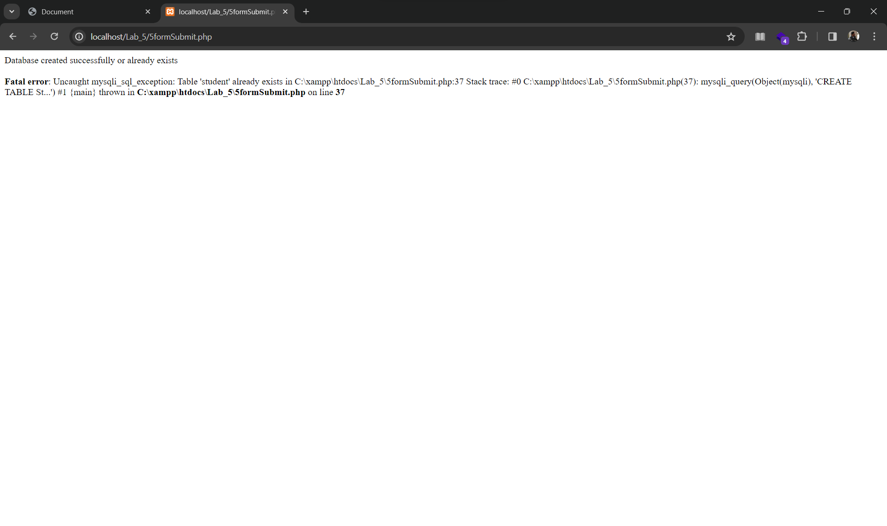 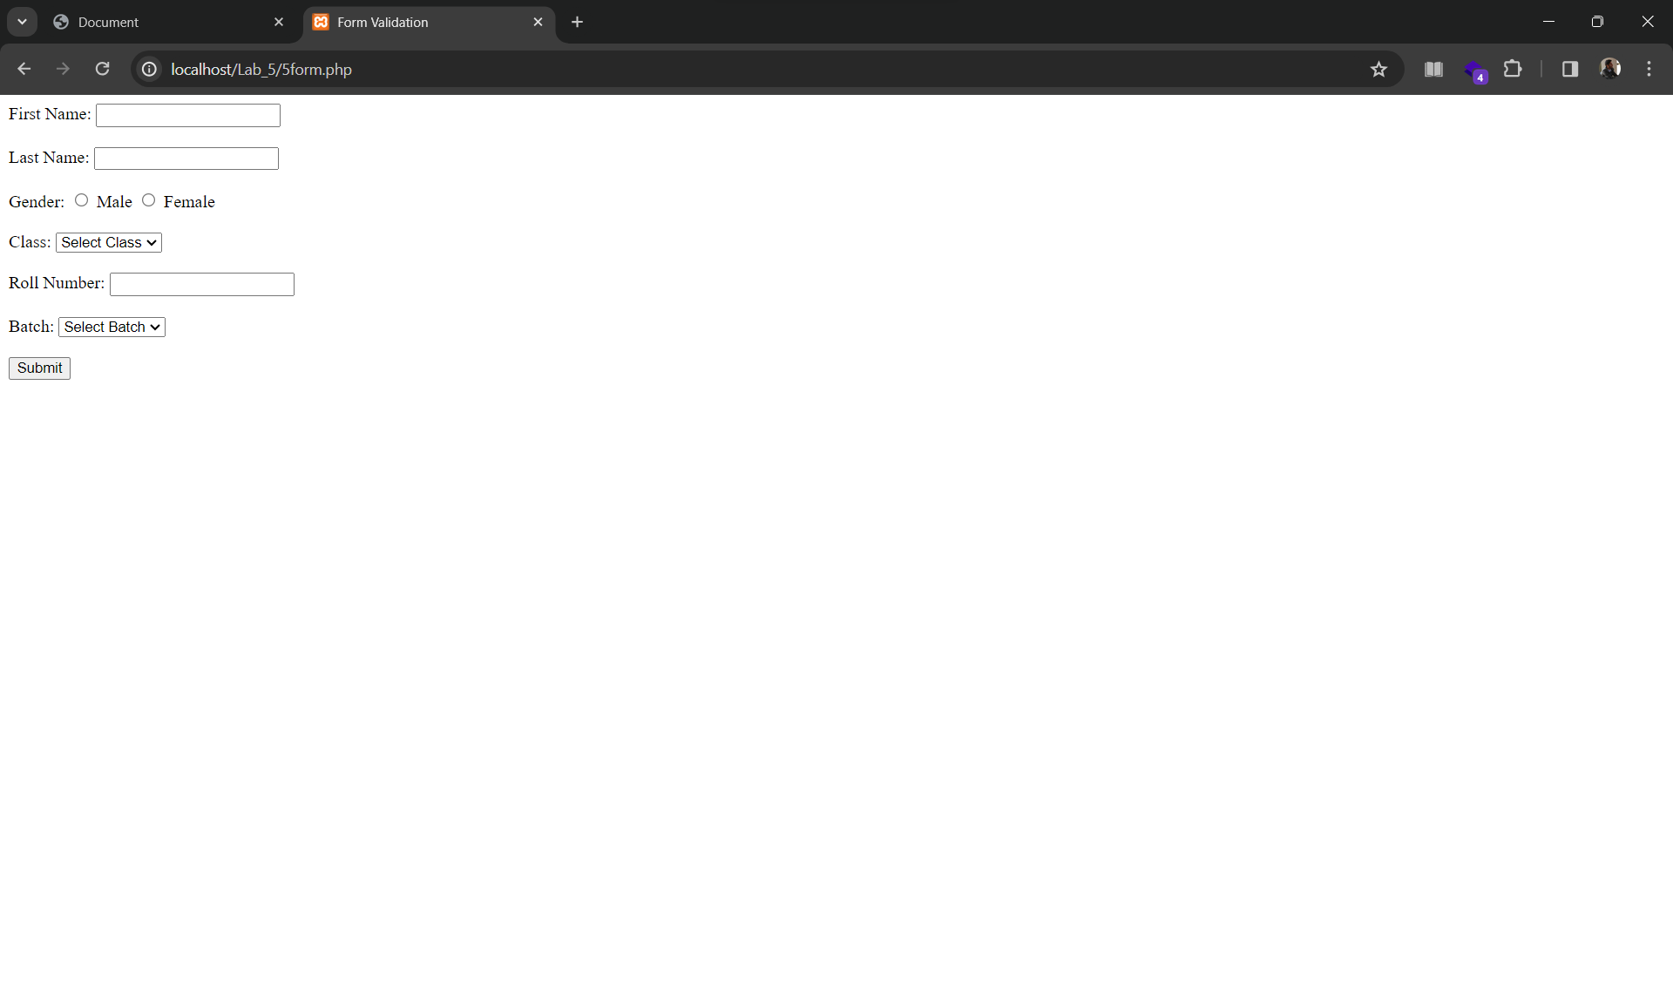

**Task 6:**

**Create a list php page which displays the data saved in Table 1**

**PHP**

***Form Submit***

<?php

$servername = 'localhost';

$username = 'root';

$password = '';

$dbname = 'test';

// Create connection

$conn = mysqli_connect($servername, $username, $password, $dbname);

// Check connection

if (!$conn) {

die("Connection Error: " . mysqli_connect_error());

}

$sql = "SELECT * FROM Student";

$query = mysqli_query($conn, $sql);

?>

<!DOCTYPE html>

<html lang="en">

<head>

<meta charset="UTF-8">

<meta name="viewport" content="width=device-width, initial-scale=1.0">

<title>Student Information</title>

</head>

<body>

<table border="1">

<tr>

<th>Firstname</th>

<th>Lastname</th>

<th>Gender</th>

<th>Class</th>

<th>Roll-No</th>

<th>Batch-no</th>

</tr>

<?php

while ($row = mysqli_fetch_assoc($query)) {

?>

<tr>

<td><?php echo $row['firstname']; ?></td>

<td><?php echo $row['lastname']; ?></td>

<td><?php echo $row['gender']; ?></td>

<td><?php echo $row['class']; ?></td>

<td><?php echo $row['rollnumber']; ?></td>

<td><?php echo $row['batch']; ?></td>

</tr>

<?php

}

?>

</table>

</body>

</html>

***Form***

<!DOCTYPE html>

<html lang="en">

<head>

<meta charset="UTF-8">

<meta name="viewport" content="width=device-width, initial-scale=1.0">

<title>Form Validation</title>

</head>

<body>

<form id="myForm" action="formSubmit.php" method="post" onsubmit="return validateForm()">

<label for="firstname">First Name:</label>

<input type="text" id="firstname" name="firstname"><br><br>

<label for="lastname">Last Name:</label>

<input type="text" id="lastname" name="lastname"><br><br>

<label>Gender:</label>

<input type="radio" id="male" name="gender" value="Male">

<label for="male">Male</label>

<input type="radio" id="female" name="gender" value="Female">

<label for="female">Female</label><br><br>

<label for="class">Class:</label>

<select id="class" name="class">

<option value="">Select Class</option>

<option value="1">Class 1</option>

<option value="2">Class 2</option>

<!-- Add more class options as needed -->

</select><br><br>

<label for="rollnumber">Roll Number:</label>

<input type="text" id="rollnumber" name="rollnumber" title="Please enter a 4-digit number"><br><br>

<label for="batch">Batch:</label>

<select id="batch" name="batch">

<option value="">Select Batch</option>

<option value="A">Batch A</option>

<option value="B">Batch B</option>

<!-- Add more batch options as needed -->

</select><br><br>

<input type="submit" value="Submit">

</form>

<script>

function validateForm() {

// Get values from the form

const firstname = document.getElementById('firstname').value;

const lastname = document.getElementById('lastname').value;

const gender = document.querySelector('input[name="gender"]:checked');

const selectedClass = document.getElementById('class').value;

const rollnumber = document.getElementById('rollnumber').value;

const selectedBatch = document.getElementById('batch').value;

// Detailed validation

if (firstname === "") {

alert("Please enter your First Name");

return false;

}

if (lastname === "") {

alert("Please enter your Last Name");

return false;

}

if (!gender) {

alert("Please select your Gender");

return false;

}

if (selectedClass === "") {

alert("Please select your Class");

return false;

}

if (rollnumber === "") {

alert("Please enter your Roll Number");

return false;

}

if (selectedBatch === "") {

alert("Please select your Batch");

return false;

}

return true;

}

</script>

</body>

</html>

**Output**



